GAME DESIGN DOCUMENT – Castle Lib 2D

## Student Card Number:

10078748

## Game Name:

Castle Lib 2d

# Game Story

## Game Backstory

An archer is the sole military survivor of an attack on the kingdom. He must defeat all the enemy soldiers and liberate each of the castles of the kingdom. All the while collecting coins that he will need in the future to raise an army to defend the kingdom.

# Character 1

## Character Name

Vladimir the Archer

## Appearance

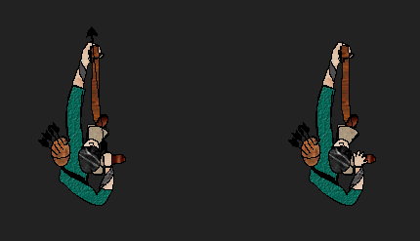

### Character Backstory

Vladimir was an archer for the Kingdom of Gordeth. Whilst away with his family, the entire Kingdom was attacked and taken over by the rebellious Knights of Blood. It is up to Vlad now to rescue his kingdom and to collect as much gold on the way as possible to help raise an army to defend the kingdom and banish the Knights of Blood once and for all.

### Stereotypes

[Hero](https://en.wikipedia.org/wiki/Hero)

[Veteran](https://en.wikipedia.org/wiki/Veteran)

[Archer](https://en.wikipedia.org/wiki/Archery)

[Lone Wolf](https://en.wikipedia.org/wiki/Lone_wolf_(trait))

# Menu System

## Menu Flowchart

Game

Game Over

Pause

Main Menu

# Menu Screens

## Main Menu Screen Diagram

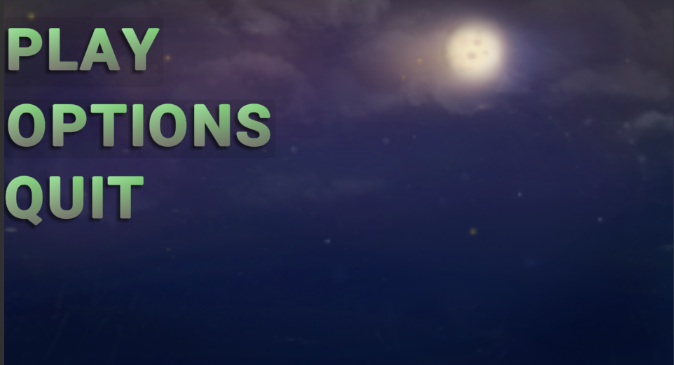

## Main Menu screen description

Play button

* Loads the game scene

Options button

* Navigates to the options scene

Quit button

* Closes the application

## Game Screen Diagram

Player Health Player Score

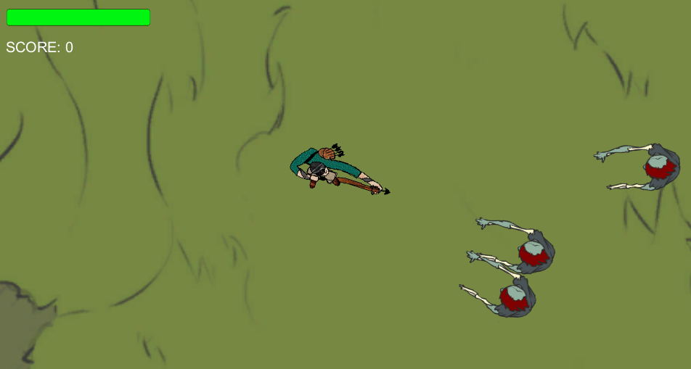

Player Entity Zombie

Player Health

* Display the player’s current health state
* When the bar is all red, the Game Over screen will load automatically

Player Score

* Displays the player’s current score (for Highscore functions)

Player Entity

* The controllable hero that is the main protagonist in the game

Zombie

* One of the enemy characters in the game who will try to seek and destroy the Hero